* Copyright for test papers and marking guides remains with *West Australian Test Papers*.
* The papers may only be reproduced within the purchasing school according to the advertised conditions of sale.
* Test papers must be withdrawn after use and stored securely in the school until October 12th.

**HUMAN BIOLOGY**

**UNITS 3 & 4**

**2023**

**Insert School Logo**

Name: _______________________________________________________

Teacher: ___________________________________________________

**Time allowed for this paper**

Reading time before commencing work: ten minutes

Working time: three hours

**Materials required/recommended for this paper**

***To be provided by the supervisor***

This Question/Answer booklet

Multiple-choice answer sheet

***To be provided by the candidate***

Standard items: pens (blue/black preferred), pencils (including coloured), sharpener, correction fluid/tape, eraser, ruler, highlighters

Special items: up to three calculators, which do not have the capacity to create or store programmes or text, are permitted in this ATAR course examination

**Important note to candidates**

No other items may be taken into the examination room. It is **your** responsibility to ensure that you do not have any unauthorised material. If you have any unauthorised material with you, hand it to the supervisor **before** reading any further.

**Structure of this paper**

|  |  |  |  |  |  |
| --- | --- | --- | --- | --- | --- |
| Section | Number of questions available | Number of questions to be answered | Suggested working time (minutes) | Marks available | Percentage of examination |
| Section One Multiple-choice | 30 | 30 | 40 | 30 | 30 |
| Section Two Short answer | 7 | 7 | 90 | 106 | 50 |
| Section Three Extended answer  Unit 3 | 2 | 1 | 50 | 20 | 20 |
| 20 |
| Unit 4 | 2 | 1 |  | 20 |
|  |  |  |  | **Total** | 100 |

**Instructions to candidates**

1. The rules for the conduct of the Western Australian examinations are detailed in the *Year 12 Information Handbook 2023: Part II Examinations*. Sitting this examination implies that you agree to abide by these rules.

2. Answer the questions according to the following instructions.

Section One: Answer all questions on the separate Multiple-choice answer sheet provided. For each question, shade the box to indicate your answer. Only use a blue or black pen to shade the boxes. Do not use erasable or gel pens. If you make a mistake, place a cross through that square, then shade your new answer. Do not erase or use correction fluid/tape. Marks will not be deducted for incorrect answers. No marks will be given if more than one answer is completed for any question.

Section Two: Write your answers in this Question/Answer booklet preferably using a blue/black pen. Do not use erasable or gel pens. Wherever possible, confine your answers to the line spaces provided.

Section Three: Consists of two parts each with two questions. You must answer one question from each part. Tick the box next to the question you are answering. Write your answers in this Question/Answer booklet preferably using a blue/black pen. Do not use erasable or gel pens.

3. You must be careful to confine your answers to the specific questions asked and to follow any instructions that are specific to a particular question.

5. Supplementary pages for planning/continuing your answers to questions are provided at the end of this Question/Answer booklet. If you use these pages to continue an answer, indicate at the original answer where the answer is continued, i.e. give the page number.

**Section One: Multiple-choice 30% (30 Marks)**

This section has **30** questions. Answer **all** questions on the separate Multiple-choice answer sheet provided. For each question shade the box to indicate your answer. Use only a blue or black pen to shade the boxes. Do not use erasable or gel pens. If you make a mistake, place a cross through that square, then shade your new answer. Do not erase or use correction fluid/tape. Marks will not be deducted for incorrect answers. No marks will be given if more than one answer is completed for any question.

Suggested working time: 40 minutes.

1. The cerebellum

(a) is involved in memory and learning.

(b) would control temperature and sleeping patterns.

(c) ensures movements are smooth and controlled.

(d) connects parts of the brain and spinal cord with each other.

2. Which of the following statements is correct? In general,

(a) the nervous system is more specific than the endocrine system.

(b) the endocrine system targets one effector at a time.

(c) messages in the nervous system have a longer persistence.

(d) the endocrine system outcomes are short lived.

Question 3 refers to the incomplete table below.

|  |  |  |
| --- | --- | --- |
| **Type of Immunity** | **Artificial Immunity** | **Natural Immunity** |
| **Active Immunity** | 1 | Someone catches a disease from their friend |
| **Passive Immunity** | A person is injected with antivenom after a snakebite | 2 |

3. Which of the following statements would be correct?

(a) 2 – A baby is vaccinated against measles, mumps and diphtheria.

(b) 1 – Someone is injected with an antibody.

(c) 2 – A 3 month old is given an antigen by its mother during breastfeeding.

(d) 1 – A person is given a subunit vaccine.

Questions 4, 5 and 6 refer to the image below showing glands of the human body.

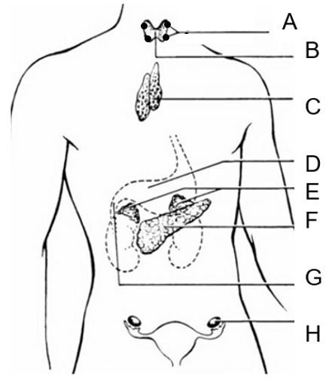

4. An overproduction of hormone from Structure B

(a) would result in an intolerance to heat.

(b) is called hypothyroidism.

(c) would cause an increase in the release of TSH.

(d) can be treated by iodine supplements.

5. Structure A

(a) releases its hormone due to the release of ACTH from the anterior pituitary.

(b) releases a hormone that regulates the levels of sodium and potassium in the blood.

(c) produces PTH due to nervous stimulation by the hypothalamus.

(d) regulates the amount of calcium in the blood.

6. The thymus

(a) contains cells that forms part of the antibody mediated immune response.

(b) is labelled structure C and produces a hormone that matures T cells.

(c) is involved in a hormone cascade that regulates body metabolism.

(d) produces TSH.

Questions 7 and 8 refer to the image below of a hominin skull.

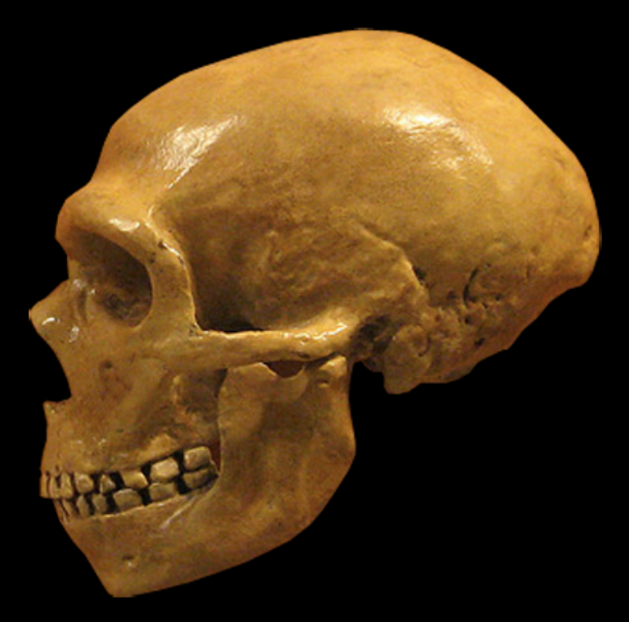

7. This hominin

(a) is *Homo erectus* due to its heavy brow ridges and large prognathism.

(b) would have lived around 300,000 to 50,000 years ago.

(c) was the first to create hand axes.

(d) had a cranial capacity of about 800cc.

8. Compared to other primates, hominins such as these

(a) would have a smaller cranial capacity than the other primates.

(b) have longer thumbs and shorter fingers than the other primates.

(c) have adaptations suited for an arboreal lifestyle.

(d) have greater prognathism and more teeth than the other primates.

9. Which of the following statements about the divisions of the nervous system is correct?

(a) The somatic nervous system can only contain motor neurons.

(b) The parasympathetic division contains two neurons in a chain in its nerve pathway.

(c) Sensory neurons use the neurotransmitter noradrenalin in the afferent nervous division.

(d) The autonomic nervous system forms part of the afferent nervous division.

Question 10 and 11 refer to the image below of a tool used by hominins.

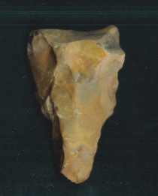

10. This type of tool

(a) is a hand axe that was first created by *Homo habilis*.

(b) would have been made by *Homo erectus*.

(c) belongs to the Oldowan tool industry.

(d) is older than 2 million years of age.

11. Tools such as these typically show

(a) more flaking than older tools.

(b) larger size than older tools.

(c) more variety in materials than younger tools.

(d) greater specialisation than younger tools.

12. Hypercalcaemia occurs when calcium levels in the blood are too high. This condition would

(a) occur as a result on the surgical removal of the parathyroid glands.

(b) stop the release of neurotransmitters from axon terminals.

(c) cause more calcitonin to be released.

(d) prevent the gut from absorbing calcium or the kidney from excreting it.

13. All of the following about carbon dioxide are correct except one. Which one is **incorrect**?

(a) Carbon dioxide impacts the medulla oblongata to stimulate breathing.

(b) Carbon dioxide levels are markedly reduced during hyperventilation.

(c) Carbon dioxide dissolves in blood plasma to form bicarbonate ions.

(d) Carbon dioxide levels have the same effect on breathing rate as oxygen levels.

Question 14 and 15 refer to the image below which shows core samples taken from one site.

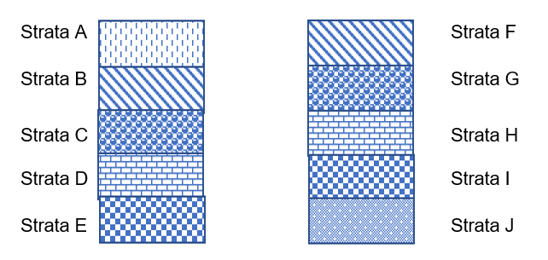

14. Strata D is

(a) older than Strata H.

(b) older than Strata F.

(c) younger than Strata C.

(d) younger than Strata G.

15. All of the following statements about these core samples are correct except one. Which one is **incorrect**?

(a) They rely on superposition to age fossils found in them.

(b) They have to be from different areas in order to date fossils through correlation of rock strata.

(c) In the layers, index fossils such as pollen could be used to date specimens.

(d) By comparing the layers, they will give an estimated age in years of specimens found in them.

16. A student collected four speeds of nerve transmission at 37oC and 20oC. The data in metres/second for 37oC were: 2.51 2.47 2.31 2.52

Which of the following is correct?

(a) The student should graph the data for 37oC and 20oC using a bar graph.

(b) The mean for the 37oC data is 2.45 metres/second.

(c) The median for the 37oC data is 2.49 metres/second.

(d) The y axis of the graph for the 37oC and 20oC data is Temperature (oC).

Question 17 refers to the image below of the standard distribution of cranium circumference

size in centimetres for newborns in 2023.

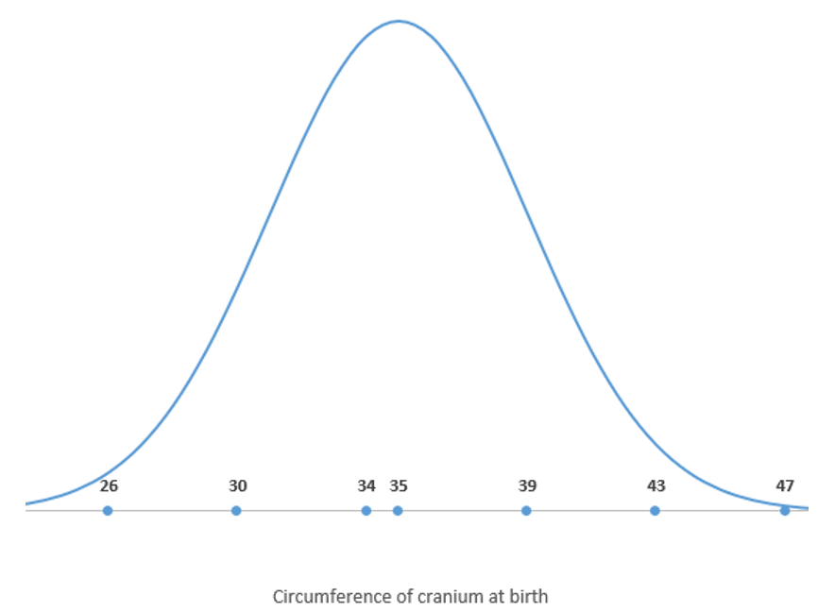

17. What could be expected for the cranium circumference of *Homo neanderthalensis* newborns?

(a) a taller, narrower curve with a mean of 35 cm

(b) a shorter broader curve with a mean of 35 cm

(c) a similar sized and shaped curve with a mean greater than 35 cm

(d) a similar sized and shaped curve with a mean less than 35 cm

18. *Homo neanderthalensis*

(a) were the first to bury their dead.

(b) only made tools out of stone.

(c) did not build shelters.

(d) created mural art.

19. Which of the following statements about radiocarbon dating is correct?

(a) It could be used on a stone tool older than 100,000 years.

(b) It relies on a half-life of 1300 million years.

(c) It utilises the breakdown of carbon 12 to carbon 14.

(d) It could be used on a wooden handle if it was younger than 70,000 years.

Question 20 and 21 refer to the skull below.

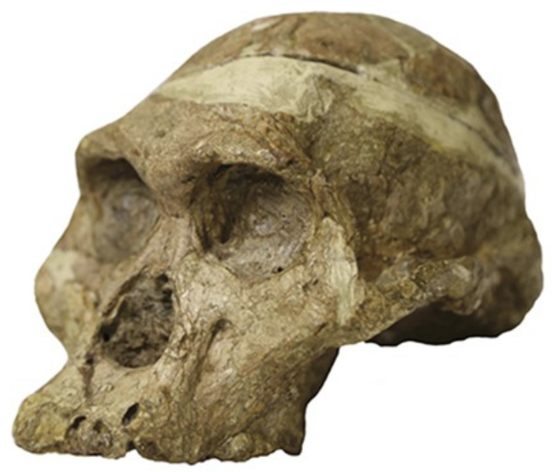

20. This individual is

(a) *Australopithecus africanus.*

(b) *Paranthropus robustus.*

(c) *Homo habilis.*

(d) *Homo erectus.*

21. This individual

(a) would be found in Europe and Asia.

(b) created tools made of bone.

(c) moved out of Africa as a nomadic hunter gatherer.

(d) had large molars and premolars.

22. The following is a list of characteristics of pathogens.

i) cell wall

ii) slime layer

iii) RNA or DNA

iv) protein coat

v) plasmids

vi) no nucleus

Which of these characteristics would be seen in bacteria?

(a) iv), v), vi)

(b) i), iii), vi)

(c) ii), iv), v)

(d) i), ii), vi)

23. “River blindness” is caused by a parasitic worm that is transmitted by the bite of blackflies. What is the mechanism of transmission for river blindness?

(a) direct contact

(b) droplets

(c) vector

(d) airborne

24. T cells and B cells

(a) are part of the second layer of defence.

(b) can be stimulated by a macrophage.

(c) are created in bone marrow.

(d) create antibodies.

25. Antibodies can act in all of the following ways, except one. Which one is **incorrect**?

(a) enhance the antigen’s reaction with other cells

(b) make soluble substances insoluble

(c) dissolve antigens

(d) bind to viral surfaces to prevent them entering cells

26. Non-disjunction

(a) occurs during mitosis.

(b) is a gene mutation.

(c) includes conditions such as Klinefelter’s syndrome.

(d) always results in more chromosomes in the daughter cell.

27. Variation does **not**

(a) occur due to sexual reproduction.

(b) result in changes in allele frequency in different populations.

(c) contribute to natural selection in populations.

(d) cause random assortment or crossing over.

28. Germ line mutations

(a) can be passed on to offspring.

(b) occur in the body cells of the affected individual.

(c) and somatic mutations do not affect offspring of affected individuals.

(d) include skin cancers.

29. A bottleneck event

(a) occurred on Pingelap Island in Micronesia after a typhoon.

(b) occurred on Pitcairn Island when the survivors of a sailing ship munity landed there.

(c) immediately results in a much larger population than before the event.

(d) causes an immediate increase in the genetic diversity of the affected population.

30. On a small, isolated island in the Atlantic Ocean, the inhabitants had never been exposed to measles. When the island was first visited by European explorers, nearly half the population died of measles, while none of the Europeans died. A second wave of measles affected the island population about 10 years later. This time, only 8% of the population died. Since then, there have been no deaths from measles.

Which of the following statements is **incorrect**?

(a) The islanders showed a primary response in the first wave of infection.

(b) The Europeans had memory cells for measles when they reached the island.

(c) Any islanders who caught measles in the second wave would not have had memory cells for measles.

(d) The symptoms of measles would have been less severe in those infected again in the second wave of infection.

**End of Section One**

**Section Two: Short answer 50% (106 Marks)**

This section has **seven** questions. Answer **all** questions. Write your answers in the spaces provided.

Supplementary pages for planning/continuing your answers to questions are provided at the end of this Question/Answer booklet. If you use these pages to continue an answer, indicate at the original answer where the answer is continued, i.e. give the page number.

Suggested working time: 90 minutes.

**Question 31 (12 marks)**

A group of Year 12 students decided to test the effect of sleep on reaction time. They asked three of their classmates to take part in the study. All three subjects were asked to complete an online reaction test before they went to bed at 10pm. One subject was allowed 2 hours sleep, another 4 hours and the last was allowed 8 hours sleep. All subjects were tested with the same online reaction test at 9am the following day.

In the online reaction test subjects had to click a button whenever they saw an animal leave its herd and run across the screen. Five animals ran at some point in each test and the average reaction time for all 5 animals was shown on the screen. If the button was clicked before an animal moved, a 0.5 second penalty was added to the students’ reaction time.

(a) What hypothesis could the students be testing? (1 mark)

__________________________________________________________________________

__________________________________________________________________________

(b) Name the dependent variable. (1 mark)

__________________________________________________________________________

(c) Identify **two** controlled variables. (2 marks)

__________________________________________________________________________

__________________________________________________________________________

(d) Draw up a table of results for their experiment. (3 marks)

(e) Using evidence, comment on the reliability of their experiment and suggest how reliability can be improved in any experiment. (3 marks)

__________________________________________________________________________

__________________________________________________________________________

__________________________________________________________________________

__________________________________________________________________________

(f) Afterwards the students discussed the validity of their experiment. They agreed they should have told their subjects what they were allowed to eat during it. Explain why failing to tell the subjects what they were allowed to eat may have affected validity.

(2 marks)

__________________________________________________________________________

__________________________________________________________________________

__________________________________________________________________________

__________________________________________________________________________

**Question 32 (14 marks)**

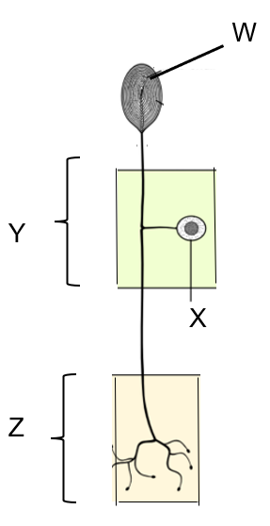

(a) Identify the type of neuron in the diagram. (1 mark)

__________________________________________________________________________

(b) This neuron is part of a reflex arc. What is the structural classification of a neuron it would synapse with in region Z? (1 mark)

__________________________________________________________________________

(c) What structures are represented by labels W and Y? (2 marks)

W _______________________________________________________________

Y _______________________________________________________________

(d) What type of matter is structure X always found in? (1 mark)

__________________________________________________________________________

(e) Reflexes are fast, automated and stereotyped. Explain the reasons for each of these characteristics. (3 marks)

__________________________________________________________________________

__________________________________________________________________________

__________________________________________________________________________

__________________________________________________________________________

__________________________________________________________________________

(f) Explain how the action potential is transferred across the synapse. (6 marks)

__________________________________________________________________________

__________________________________________________________________________

__________________________________________________________________________

__________________________________________________________________________

__________________________________________________________________________

__________________________________________________________________________

__________________________________________________________________________

__________________________________________________________________________

__________________________________________________________________________

**Question 33 (17 marks)**

The following image shows a hormone cascade.

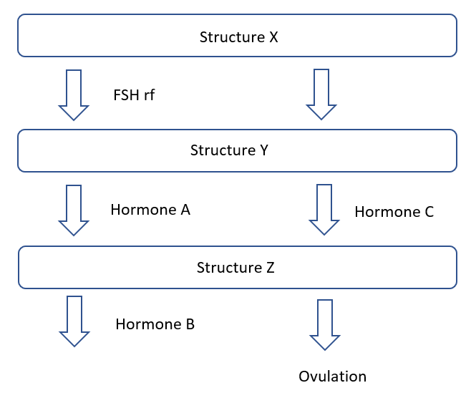

(a) Name structures X and Z. (2 marks)

X _______________________________________________________________

Z _______________________________________________________________

(b) Explain how structure X communicates with structure Y. (1 mark)

__________________________________________________________________________

(c) Hormone A and Hormone B have different modes of action. Compare and contrast their modes of action. (5 marks)

__________________________________________________________________________

__________________________________________________________________________

__________________________________________________________________________

__________________________________________________________________________

__________________________________________________________________________

__________________________________________________________________________

__________________________________________________________________________

__________________________________________________________________________

(d) State the effect of Hormone C in males. (1 mark)

__________________________________________________________________________

__________________________________________________________________________

(e) Hormone A is made synthetically and given to women undergoing in-vitro fertilisation. Name the process that would be used to make Hormone A in this way and describe the role of the chemicals required for this process to take place. (7 marks)

__________________________________________________________________________

__________________________________________________________________________

__________________________________________________________________________

__________________________________________________________________________

__________________________________________________________________________

__________________________________________________________________________

__________________________________________________________________________

__________________________________________________________________________

__________________________________________________________________________

__________________________________________________________________________

__________________________________________________________________________

__________________________________________________________________________

(f) Structure Y also controls the amount of sodium and potassium in the blood. Explain how Structure Y is able to do this. (1 mark)

__________________________________________________________________________

__________________________________________________________________________

**Question 34 (9 marks)**

Gel electrophoresis is often used to identify different lengths of DNA. In the same way, it can also be used to identify the different amino acids that form parts of a protein, as the different amino acids have different lengths.

(a) At which electrode would you find the longest amino acid chains on an agarose gel?

(1 mark)

__________________________________________________________________________

(b) The amino acid sequence of cytochrome C was studied in this way in order to determine the degree of relationship between different species. What is the term given to proteins like cytochrome C that are found in many species? (1 mark)

__________________________________________________________________________

The same portion of cytochrome C protein of four different species was placed on an agarose

gel and the results are tabulated below.

|  |  |  |  |  |
| --- | --- | --- | --- | --- |
| Species | Amino acid A | Amino acid B | Amino acid C | Amino acid D |
| 1 | Ala | Gly | Arg | Lys |
| 2 | Arg | Val | Pro | Lys |
| 3 | Ala | Gly | Lys | Lys |
| 4 | Pro | Gly | Arg | Asn |

(c) Which two species are most closely related? (1 mark)

__________________________________________________________________________

(d) A student created a phylogenetic tree based on this data, which is shown below.

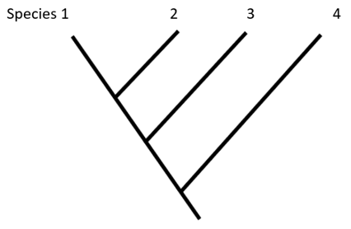

Explain whether this phylogenetic tree is correct. (2 marks)

__________________________________________________________________________

__________________________________________________________________________

__________________________________________________________________________

__________________________________________________________________________

(e) Further study indicated that a mutation had occurred in Species 4. The DNA codon of amino acid D that generated Lys was AAG while the amino acid Asn is determined by the codon AAT. Classify this type of mutation. (1 mark)

__________________________________________________________________________

__________________________________________________________________________

(f) Name **two** mutagens and explain the effect of any mutagen. (3 marks)

__________________________________________________________________________

__________________________________________________________________________

__________________________________________________________________________

__________________________________________________________________________

**Question 35 (19 marks)**

Sickle cell anaemia is a genetic condition that affects the shape of red blood cells and has a different rate of incidence in different populations.

(a) Discuss how selection pressures and gene flow would have altered the frequency of sickle cell disease in different populations. (6 marks)

__________________________________________________________________________

__________________________________________________________________________

__________________________________________________________________________

__________________________________________________________________________

__________________________________________________________________________

__________________________________________________________________________

__________________________________________________________________________

__________________________________________________________________________

(b) The incidence of sickle cell anaemia is a good case study for the process of natural selection. What is natural selection? (2 marks)

__________________________________________________________________________

__________________________________________________________________________

__________________________________________________________________________

(c) Explain how isolation contributes to speciation in a population. (4 marks)

__________________________________________________________________________

__________________________________________________________________________

__________________________________________________________________________

__________________________________________________________________________

__________________________________________________________________________

__________________________________________________________________________

(d) For those heterozygous for sickle cell disease, dehydration can often trigger a sickle crisis. Explain how water conditions are normally maintained in our body. (5 marks)

__________________________________________________________________________

__________________________________________________________________________

__________________________________________________________________________

__________________________________________________________________________

__________________________________________________________________________

__________________________________________________________________________

__________________________________________________________________________

(e) It was suggested that gene therapy could be used to treat sickle cell anaemia. Give one reason why gene therapy would be a good candidate as a treatment for this condition and one reason why it would not be. (2 marks)

__________________________________________________________________________

__________________________________________________________________________

__________________________________________________________________________

__________________________________________________________________________

**Question 36 (20 marks)**

Lee and Vinuesa observed the rapid rise in autoimmune diseases such as lupus, diabetes, multiple sclerosis and inflammatory bowel disease over the last 40 years and decided to study the DNA sequence of people suffering from these conditions. They indicated that where once half a dozen DNA variants were known to trigger inflammatory bowel disease, now, due to bioinformatics, over 250 variants are known.

(a) Define bioinformatics and explain how it would have contributed to the knowledge base about autoimmune diseases. (2 marks)

__________________________________________________________________________

__________________________________________________________________________

__________________________________________________________________________

__________________________________________________________________________

(b) PCR was a crucial part of Lee and Vinuesa’s study. Give a reason why PCR was required and explain what substances are needed in order for it to be conducted. (5 marks)

__________________________________________________________________________

__________________________________________________________________________

__________________________________________________________________________

__________________________________________________________________________

__________________________________________________________________________

__________________________________________________________________________

__________________________________________________________________________

__________________________________________________________________________

(c) Differentiate between Type I and Type II diabetes. (4 marks)

__________________________________________________________________________

__________________________________________________________________________

__________________________________________________________________________

__________________________________________________________________________

__________________________________________________________________________

__________________________________________________________________________

__________________________________________________________________________

__________________________________________________________________________

(d) Untreated diabetes can result in neuropathy in the extremities, where inflammation and damage to sensory neurons result in pain. Name the receptors capable of detecting pain and state the main way in which they are different to all other types of receptors. (2 marks)

__________________________________________________________________________

__________________________________________________________________________

__________________________________________________________________________

(e) Multiple sclerosis results in the destruction of myelin. Explain how an action potential would normally be transmitted through a myelinated neuron. (7 marks)

__________________________________________________________________________

__________________________________________________________________________

__________________________________________________________________________

__________________________________________________________________________

__________________________________________________________________________

__________________________________________________________________________

__________________________________________________________________________

__________________________________________________________________________

__________________________________________________________________________

__________________________________________________________________________

__________________________________________________________________________

__________________________________________________________________________

**Question 37 (15 marks)**

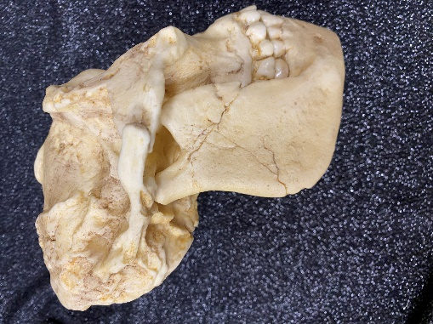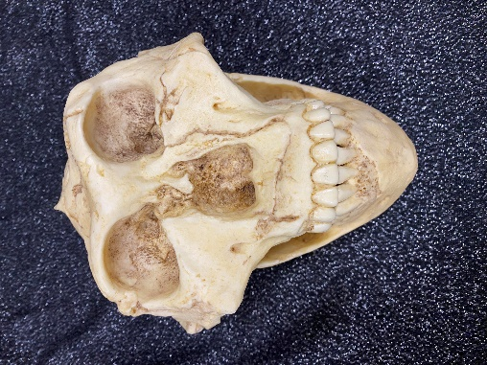

The individual shown in the two images above was dated at approximately 2 million years of age.

(a) Name this species. (1 mark)

__________________________________________________________________________

(b) (i) State the anatomical feature this individual has that is not shared by any other

hominin. (1 mark)

____________________________________________________________________

(ii) Explain how this feature would have become more common in this population over time. (7 marks)

____________________________________________________________________

____________________________________________________________________

____________________________________________________________________

____________________________________________________________________

____________________________________________________________________

____________________________________________________________________

____________________________________________________________________

____________________________________________________________________

____________________________________________________________________

____________________________________________________________________

____________________________________________________________________

____________________________________________________________________

____________________________________________________________________

____________________________________________________________________

____________________________________________________________________

(c) *Homo sapiens* has been found throughout the world but is believed to have originated in Africa.

(i) State the anatomical structure present in this species that is not present in any other hominin and suggest the advantage of having such a structure.

(2 marks)

_______________________________________________________________

______________________________________________________________________________________________________________________________

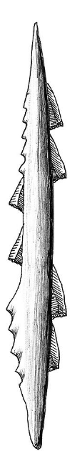

(ii) State **two** different cultural aspects of *Homo sapiens* (Cro magnon) that set it apart from other hominins. (2 marks)

_______________________________________________________________

______________________________________________________________________________________________________________________________

(iii)

This tool was found with a *Homo sapiens* (Cro magnon) specimen in a cave in France. State the tool culture this tool would have been classified as and give one use of such a tool. (2 marks)

_______________________________________________________________

______________________________________________________________________________________________________________________________

**End of Section Two**

**Section Three: Extended answer 20% (40 Marks)**

This section contains **four** questions. You must answer **two** questions.

Questions 38 and 39 are from Unit 3. Questions 40 and 41 are from Unit 4. Answer **one** question from Unit 3 and **one** question from Unit 4.

Responses could include clearly labelled diagrams with explanatory notes; lists of points with linking sentences; clearly labelled tables and graphs; and annotated flow diagrams with introductory notes.

Supplementary pages for planning/continuing your answers to questions are provided at the end of this Question/Answer booklet. If you use these pages to continue an answer, indicate at the original answer where the answer is continued, i.e. give the page number.

Suggested working time: 50 minutes

_________________________________________________________________________

**Unit 3**

Choose **either** Question 38 **or** Question 39.

Indicate the question you will answer by ticking the box next to the question. Write your answer on pages 28-32. When you have answered your first question, turn to page 33 and indicate on that page the second question you will answer.

_________________________________________________________________________

**Question 38 (20 marks)**

Aisha went outside to do some trimming in the garden and noticed a small cut on her finger as she put her gloves on. Later that afternoon when she cleaned up she noticed the cut’s appearance had changed.

(a) Describe the changes in appearance Aisha would have noticed and provide an explanation for these changes. (10 marks)

(b) Later that night, Aisha started feeling cold and unwell, so she went to bed early. Describe how and why fever occurs and explain what type of immunity this process provides. (10 marks)

**or**

**Question 39 (20 marks)**

Due to the wind and waves, Oliver capsized his small boat and fell into the cold ocean water. He could only tread water while he watched his boat sink.

(a) Discuss the mechanisms of heat transfer which would have resulted in Oliver losing heat when he was in the water. (6 marks)

(b) Body temperature can be regulated using both nervous and endocrine methods. Describe both of these physiological mechanisms that would have been employed in response to his situation in order to maintain his temperature homeostasis. (10 marks)

(c) In this stressful time, Oliver’s adrenal gland would have released adrenalin. Explain why this could be both advantageous and disadvantageous to Oliver at this time.

(4 marks)

Question number: ________________

__________________________________________________________________________________________________________________________________________________

_________________________________________________________________________

_________________________________________________________________________

_________________________________________________________________________

_________________________________________________________________________

__________________________________________________________________________________________________________________________________________________

_________________________________________________________________________

_________________________________________________________________________

_________________________________________________________________________

_________________________________________________________________________

__________________________________________________________________________________________________________________________________________________

_________________________________________________________________________

_________________________________________________________________________

_________________________________________________________________________

_________________________________________________________________________

__________________________________________________________________________________________________________________________________________________

_________________________________________________________________________

_________________________________________________________________________

_________________________________________________________________________

_________________________________________________________________________

__________________________________________________________________________________________________________________________________________________

Question number: ________________

__________________________________________________________________________________________________________________________________________________

_________________________________________________________________________

_________________________________________________________________________

_________________________________________________________________________

_________________________________________________________________________

__________________________________________________________________________________________________________________________________________________

_________________________________________________________________________

_________________________________________________________________________

_________________________________________________________________________

_________________________________________________________________________

__________________________________________________________________________________________________________________________________________________

_________________________________________________________________________

_________________________________________________________________________

_________________________________________________________________________

_________________________________________________________________________

__________________________________________________________________________________________________________________________________________________

_________________________________________________________________________

_________________________________________________________________________

_________________________________________________________________________

_________________________________________________________________________

_________________________________________________________________________

_________________________________________________________________________

Question number: ________________

__________________________________________________________________________________________________________________________________________________

_________________________________________________________________________

_________________________________________________________________________

_________________________________________________________________________

_________________________________________________________________________

__________________________________________________________________________________________________________________________________________________

_________________________________________________________________________

_________________________________________________________________________

_________________________________________________________________________

_________________________________________________________________________

__________________________________________________________________________________________________________________________________________________

_________________________________________________________________________

_________________________________________________________________________

_________________________________________________________________________

_________________________________________________________________________

__________________________________________________________________________________________________________________________________________________

_________________________________________________________________________

_________________________________________________________________________

_________________________________________________________________________

_________________________________________________________________________

_________________________________________________________________________

_________________________________________________________________________

Question number: ________________

__________________________________________________________________________________________________________________________________________________

_________________________________________________________________________

_________________________________________________________________________

_________________________________________________________________________

_________________________________________________________________________

__________________________________________________________________________________________________________________________________________________

_________________________________________________________________________

_________________________________________________________________________

_________________________________________________________________________

_________________________________________________________________________

__________________________________________________________________________________________________________________________________________________

_________________________________________________________________________

_________________________________________________________________________

_________________________________________________________________________

_________________________________________________________________________

__________________________________________________________________________________________________________________________________________________

_________________________________________________________________________

_________________________________________________________________________

_________________________________________________________________________

_________________________________________________________________________

_________________________________________________________________________

________________________________________________________________________

Question number: ________________

__________________________________________________________________________________________________________________________________________________

_________________________________________________________________________

_________________________________________________________________________

_________________________________________________________________________

_________________________________________________________________________

__________________________________________________________________________________________________________________________________________________

_________________________________________________________________________

_________________________________________________________________________

_________________________________________________________________________

_________________________________________________________________________

__________________________________________________________________________________________________________________________________________________

_________________________________________________________________________

_________________________________________________________________________

_________________________________________________________________________

_________________________________________________________________________

__________________________________________________________________________________________________________________________________________________

_________________________________________________________________________

_________________________________________________________________________

_________________________________________________________________________

_________________________________________________________________________

_________________________________________________________________________

________________________________________________________________________

**Unit 4**

Choose **either** Question 40 **or** Question 41.

Indicate the question you will answer by ticking the box next to the question. Write your answer on the pages provided.

_________________________________________________________________________

**Question 40 (20 marks)**

The earliest fossils of *Homo erectus* were discovered by a Dutch army surgeon, Eugene Dubois, on the island of Java (which has many active volcanos) in 1890. More of these specimens were found throughout Asia, particularly in the caves of Zhoukoudian.

(a) Describe factors that may have contributed to only a few fossil specimens being found on Java and suggest why the number of specimens of *Homo erectus* found in caves tends to be quite high. (8 marks)

(b) Describe the features of *Homo erectus* that would indicate the species was adapted for bipedalism. (12 marks)

**or**

**Question 41 (20 marks)**

*Homo habilis* fossils were first found in Olduvai Gorge in northern Tanzania but specimens found in Koobi Fora in Kenya allowed researchers to realise these hominins were anatomically different from the Australopithecines. Importantly, some of the Koobi Fora specimens were also found with stone tools in volcanic ash.

(a) Name the specific type of dating method that could be used to date these Koobi Fora fossils, explain the process and discuss its limitations. (8 marks)

(b) It has been stated that the cognitive ability and lifestyle of *Homo habilis* was markedly different to that of the Australopithecines who lived at the same time. Discuss this statement with reference to anatomical and cultural aspects of *Homo habilis*.

(12 marks)

**End of questions**

Question number: ________________

__________________________________________________________________________________________________________________________________________________

_________________________________________________________________________

_________________________________________________________________________

_________________________________________________________________________

_________________________________________________________________________

__________________________________________________________________________________________________________________________________________________

_________________________________________________________________________

_________________________________________________________________________

_________________________________________________________________________

_________________________________________________________________________

__________________________________________________________________________________________________________________________________________________

_________________________________________________________________________

_________________________________________________________________________

_________________________________________________________________________

_________________________________________________________________________

_________________________________________________________________________

_________________________________________________________________________

_________________________________________________________________________

_________________________________________________________________________

_________________________________________________________________________

__________________________________________________________________________________________________________________________________________________

_________________________________________________________________________

Question number: ________________

__________________________________________________________________________________________________________________________________________________

_________________________________________________________________________

_________________________________________________________________________

_________________________________________________________________________

_________________________________________________________________________

__________________________________________________________________________________________________________________________________________________

_________________________________________________________________________

_________________________________________________________________________

_________________________________________________________________________

_________________________________________________________________________

__________________________________________________________________________________________________________________________________________________

_________________________________________________________________________

_________________________________________________________________________

_________________________________________________________________________

_________________________________________________________________________

__________________________________________________________________________________________________________________________________________________

_________________________________________________________________________

_________________________________________________________________________

_________________________________________________________________________

__________________________________________________________________________________________________________________________________________________

_________________________________________________________________________

Question number: ________________

__________________________________________________________________________________________________________________________________________________

_________________________________________________________________________

_________________________________________________________________________

_________________________________________________________________________

_________________________________________________________________________

__________________________________________________________________________________________________________________________________________________

_________________________________________________________________________

_________________________________________________________________________

_________________________________________________________________________

_________________________________________________________________________

__________________________________________________________________________________________________________________________________________________

_________________________________________________________________________

_________________________________________________________________________

_________________________________________________________________________

_________________________________________________________________________

__________________________________________________________________________________________________________________________________________________

_________________________________________________________________________

_________________________________________________________________________

_________________________________________________________________________

_________________________________________________________________________

_________________________________________________________________________

_________________________________________________________________________

Question number: ________________

__________________________________________________________________________________________________________________________________________________

_________________________________________________________________________

_________________________________________________________________________

_________________________________________________________________________

_________________________________________________________________________

__________________________________________________________________________________________________________________________________________________

_________________________________________________________________________

_________________________________________________________________________

_________________________________________________________________________

_________________________________________________________________________

__________________________________________________________________________________________________________________________________________________

_________________________________________________________________________

_________________________________________________________________________

_________________________________________________________________________

_________________________________________________________________________

__________________________________________________________________________________________________________________________________________________

_________________________________________________________________________

_________________________________________________________________________

_________________________________________________________________________

_________________________________________________________________________

_________________________________________________________________________

_________________________________________________________________________

Question number: ________________

__________________________________________________________________________________________________________________________________________________

_________________________________________________________________________

_________________________________________________________________________

_________________________________________________________________________

_________________________________________________________________________

__________________________________________________________________________________________________________________________________________________

_________________________________________________________________________

_________________________________________________________________________

_________________________________________________________________________

_________________________________________________________________________

__________________________________________________________________________________________________________________________________________________

_________________________________________________________________________

_________________________________________________________________________

_________________________________________________________________________

_________________________________________________________________________

__________________________________________________________________________________________________________________________________________________

_________________________________________________________________________

_________________________________________________________________________

_________________________________________________________________________

_________________________________________________________________________

_________________________________________________________________________

________________________________________________________________________

Supplementary page

Question number: ________________

__________________________________________________________________________________________________________________________________________________

_________________________________________________________________________

_________________________________________________________________________

_________________________________________________________________________

_________________________________________________________________________

__________________________________________________________________________________________________________________________________________________

_________________________________________________________________________

_________________________________________________________________________

_________________________________________________________________________

_________________________________________________________________________

__________________________________________________________________________________________________________________________________________________

_________________________________________________________________________

_________________________________________________________________________

_________________________________________________________________________

_________________________________________________________________________

__________________________________________________________________________________________________________________________________________________

_________________________________________________________________________

_________________________________________________________________________

_________________________________________________________________________

_________________________________________________________________________

_________________________________________________________________________

**ACKNOWLEDGEMENTS**

Questions 4, 5 and 6

<https://www.flickr.com/photos/internetarchivebookimages/20549349018>

Accessed 18th March 2023

Questions 7 and 8

<https://commons.wikimedia.org/wiki/File:Sapiens_XXX_comparison_en_blackbackground.png>

Accessed 18th March 2023

Questions 10 and 11

<https://commons.wikimedia.org/wiki/File:583_three_XXXs_ventral_(FindID_101523).jpg>

Accessed 18th March 2023

Questions 20 and 21

<https://commons.wikimedia.org/wiki/File:Sts5_(XXX).png>

Accessed 18th March 2023

Question 32

<https://commons.wikimedia.org/wiki/File:Structure_of_XXX_system_(4_models)_E.PNG>

Modified

Accessed 18th March 2023

Question 37 (c) (iii)

<https://commons.wikimedia.org/wiki/File:Proyectiles_oseos_XXX.jpg>

Accessed 29th March 2023